Short note on wavelet estimation in CRAVA: By Odd Kolbjørnsen

Standard wavelet estimation
In current CAVA we use a standard estimation method, which is based on (White 1984).
This method estimates a 1D wavelet from well log and seismic data sampled into the well log. The vertical reference in the well is time, so dept to time conversion must be preformed prior to estimation. The well must be almost vertical, i.e. small deviations are tolerated. We estimate each angle separately.

From the well we obtain the reflection coefficients, 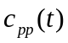, from seismic cube we sample the seismic into the well log to obtain the seismic data in the well, i.e. 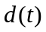.
We use the modeling relation:
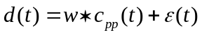
Where is the wavelet, and is the error. The standard wavelet estimation now assumes that the wavelet does not wary over the interval, and that the error is stationary.
A stationary error does not mean that it is constant, but that the expected deviation is constant over the interval. If an infinitely amount of data is available, the wavelet is easily estimated by relation .

First Fourier transform relation , multiply with the reflection coefficient and take the expectation. This gives:
In the well the only thing that is unknown in this relation is the wavelet. This means that the wavelet can be obtained directly from this relation. Since we do not have an infinite amount of data we must use data from neighboring frequencies to make the estimate more robust. This is done by Fourier transforming the relations in expression back to time domain. In time domain the left hand side relation is the cross correlation between data and reflection coefficients, 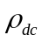. The expression 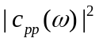 is the correlation of the reflection coefficients, 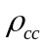. These are estimated from data and multiplied with a tapering function. We use the standard Papoulis taper, see Figure 1. Note that tapering in the time domain is identical to smoothing in the frequency domain. Thus the tapering stabilizes the estimates in Fourier domain, see Figure 2. The wavelet estimate is thus found by dividing the red curve to the right in Figure 2 by the red curve to the left. Figure 3 show the difference in the wavelet estimate when the raw correlations are used compared with the smoothed correlations.

Note that the tapering function has its peak at zero thus if there is a mismatch between the data and the reflection coefficients, the estimate will deteriorate. In CRAVA we therefore shift the peak of the correlation to zero before we apply the tapering function. This is equivalent to perform a bulk shift of the data.

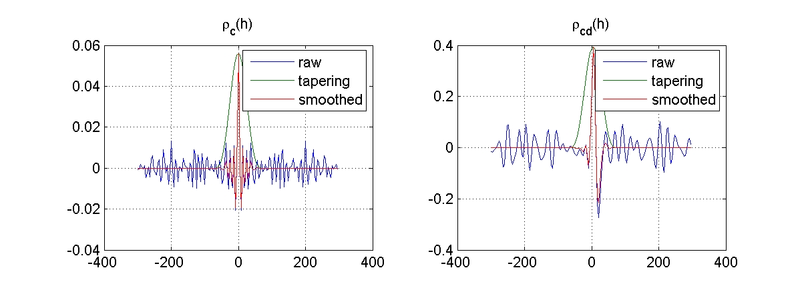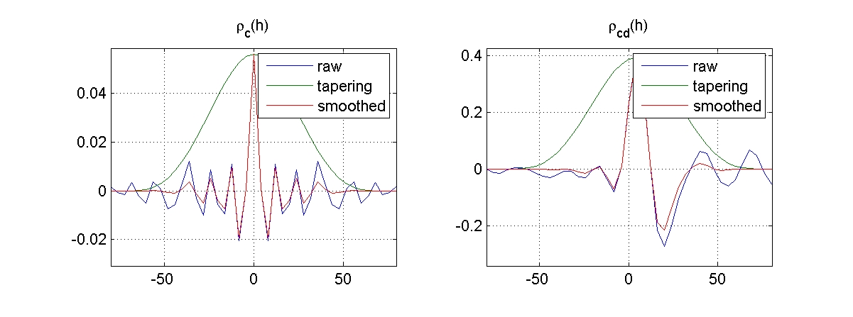

Figure 1: Raw correlations, tapering function, and estimated correlations. Top two are on a full scale, bottom two are zoomed in.

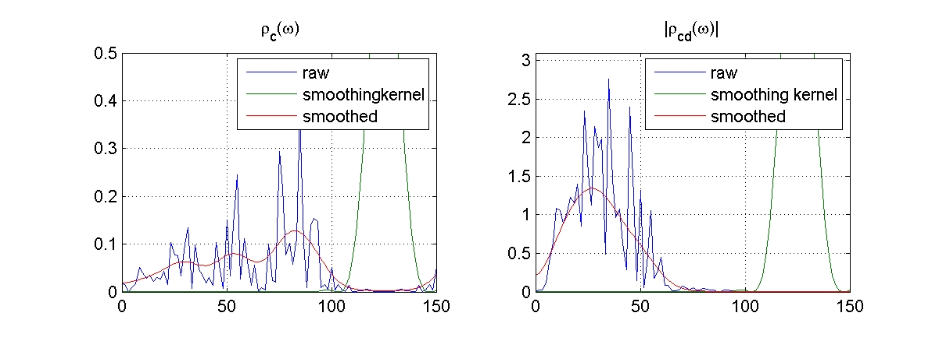
Figure 2: The Fourier transform of the correlation functions from Figure 1.

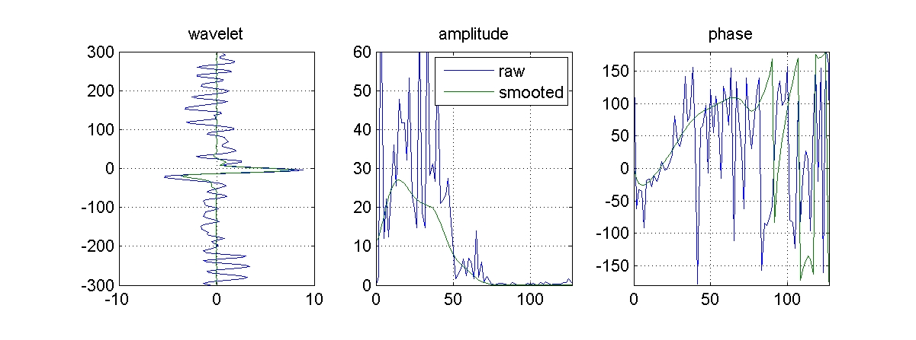
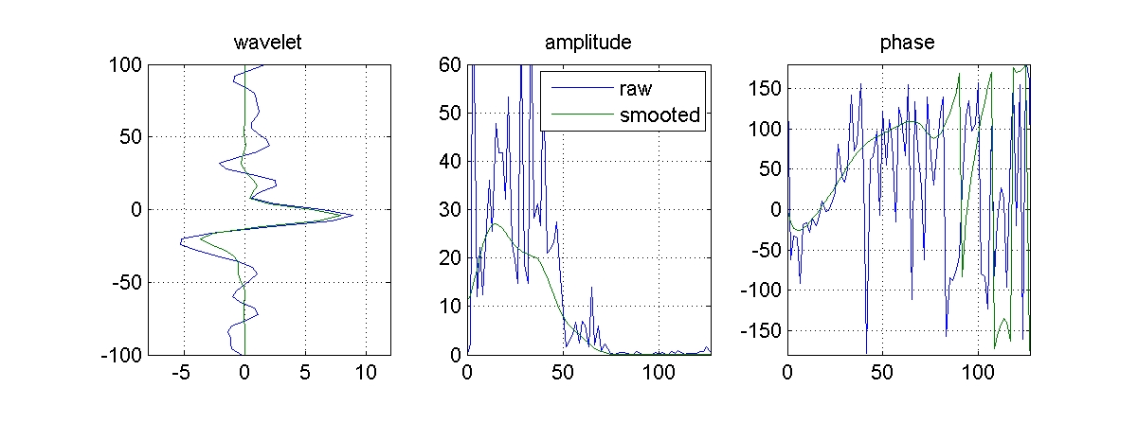
Figure 3: Estimated wavelet from raw and smoothed correlations. Top wavelet is on a full scale, bottom wavelet is zoomed in.

Estimation from multiple wells in CRAVA.
In CRAVA we estimate the wavelet from many wells. We then estimate the wavelet for each well separately, and compute an estimate of the wavelet shape as a weighted average of all wells. After the shape is obtained, we estimate the optimal scale of the wavelet. This is obtained by using the scale that minimizes the residuals for all wells.
CRAVA also report the scale that minimizes the residuals for each individual well. If these two scales are very different, this is an indication of a bad local fit.

Bayesian wavelet estimation
In a project for Statoil we have also developed a Bayesian wavelet estimation that simultaneously estimates a continuous time shift and wavelets for all angles see attached abstract. Currently we do not consider this approach to be so much better than the standard method that it is worth the extra effort in a “fast” approach such as CRAVA. If a better wavelet estimate is obtained outside CRAVA this can be used as input to CRAVA.

